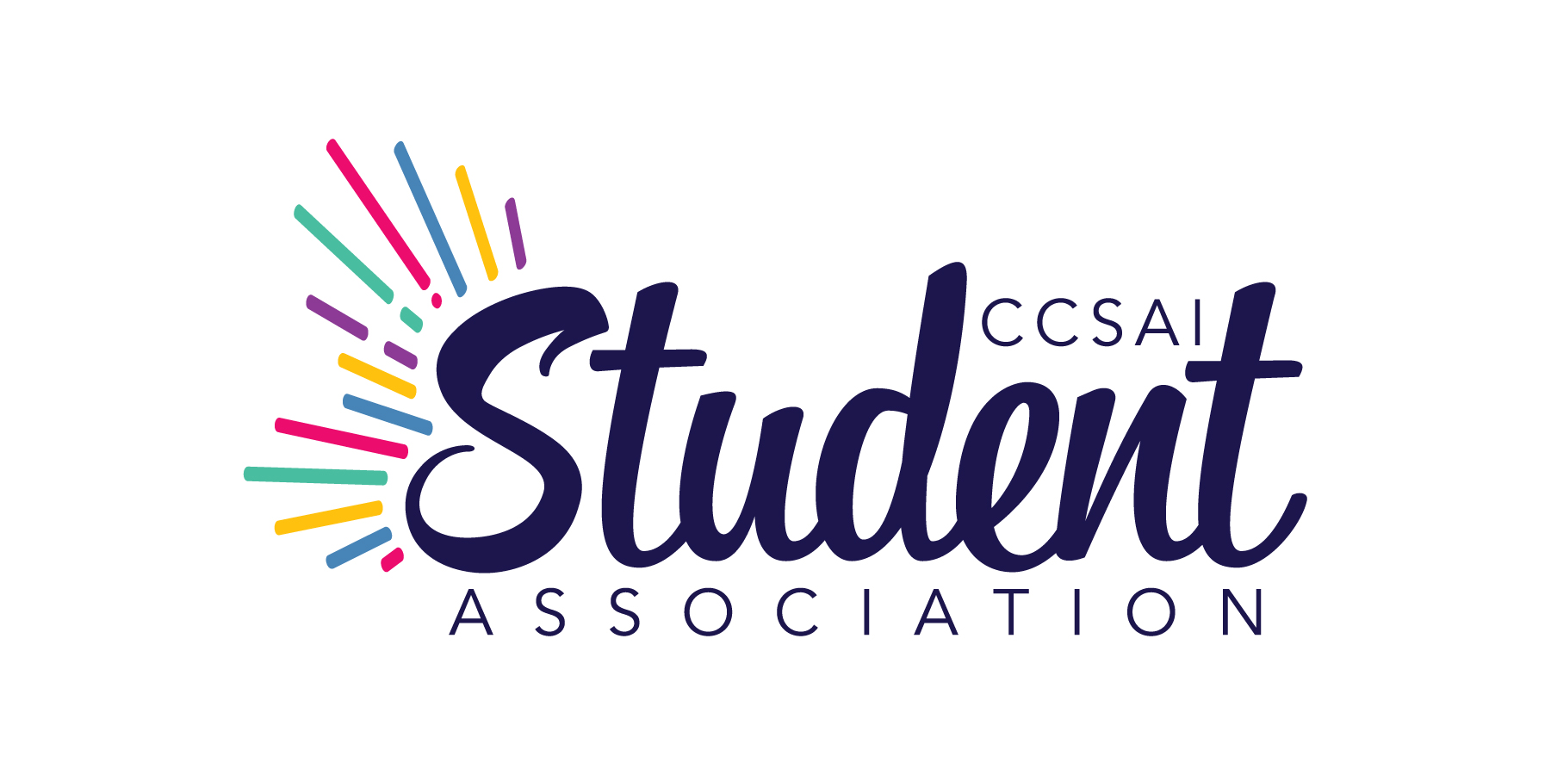
CENTENNIAL COLLEGE STUDENT ASSOCIATION INC.

FULL BOARD MEETING
Friday, November 15, 2024 at 7:30 a.m.
Held via Zoom videoconference

MINUTES

Present: A. Adams - President
B. Kaur - Vice President, Morningside Campus
K. Singh - Vice President, Downsview Centre Campus
K.M. Herrera - Vice President, Progress Campus
R. Olawoyin - Vice President, Ashtonbee Campus
L. Routhier - Representative, Performing Arts Centre
A. (Mukwa) Ladouceur - Indigenous Student Representative
P. Kirlik - Executive Director/CEO
D. Ip Yam - Dean of Students, Centennial College

Staff: A. Tumber - Research Coordinator
J. Perri - Advocacy Coordinator

Guests: Dr. N. Buddel - VP Student Experience and Success
(departed at 7:58 a.m.)
L. White - Associate VP Enrolment Services and Registrar (departed at 7:58 a.m.)
H. Neubrand - VP of Finance and Chief Financial Officer
(departed at 7:58 a.m.)

By Invitation: Anna Nutovich - Recording Secretary, MinuteTakers Inc.

Absent: V. Eke - Vice President, Story Arts Centre

Motions will include the count of votes for, against and abstentions. The count will be shown as follows: (FOR – AGAINST – ABSTAINED).

1. CALL TO ORDER

Notice having been given and there being a quorum present, the President called the meeting to order at 7:32 a.m. and presided as Chair.

2. LAND ACKNOWLEDGEMENT

K. M. Herrera read out the land acknowledgment statement.

3. CONSENT AGENDA

- Remove Item 10 - Filling Vacancies – This item will be discussed at the December 2024 meeting.

On Motion by K. Singh and seconded by B. Kaur it was:
RESOLVED THAT the following items as contained in the Consent Agenda of November 15, 2024 be duly approved and adopted as amended:
- Conflict of Interest
- Approval of Agenda as amended
Motion carried (5-0-0).

4. APPROVAL OF MINUTES

4.1 October 25, 2024 Full Board Meeting Minutes

On Motion by K. M. Herrera and seconded by B. Kaur it was:
RESOLVED THAT the minutes of the Full Board Meeting of October 25, 2024 be duly approved and adopted as presented.
Motion carried (5-0-0).

5. ANCILLARY FEE – L. White presented:

(a) Summary – The 2025-2026 Ancillary fees summary was presented.

(b) Institution Fees – The list of Institution Fees was provided.

(c) Program – L. White noted that there are mostly reductions under 2025-2026 Program Ancillary Fees.

(d) Increase – There is a proposed increase of 18.3%. Current year Compulsory Ancillary Fees total for two semesters: Year 1 ($1,097.32), Year 2 ($1,020.82). Proposed Compulsory Ancillary Fees total for two semesters: Year 1 ($1,298.94), Year 2 ($1,208.13).

On Motion by B. Kaur and seconded by K. Singh it was:
RESOLVED THAT the 2025-2026 Ancillary Fees be approved.
Motion carried (5-0-0).

6. INTERNATIONAL STUDENT TUITION FEES – H. Neubrand presented:

(a) Financial Landscape – H. Neubrand outlined the changes in the financial landscape.

(b) Competitive Environment – The majority of Ontario Colleges who have shared plans are contemplating 3% increase. The college is in line with competitors. Certain programs may be priced towards the higher end of the competitive data set are being reviewed. For these, there may be no increase recommended. Canada’s international tuition fees remain competitive with the main global competitors like US, UK, Australia and New Zealand.

(c) Student Sentiment – Ontario College Student Associations for International Tuition Equity Coalition Calls to Action included a 3% cap on increases and Cohort Pricing. Centennial adhered to these the past two years, i.e.: 3% for new students, no increase for returning students. Applying fee increases for new students only allows international students consistent fees across all years of study but resulted in approximately $6 million per year of foregone revenue.

(d) Next Steps – The College will be proposing a tuition fee increase of 3%.

(e) Transparency – It was pointed out that it was not required to bring this information to the Committee and this was done as a courtesy.

(f) Package – K.M. Herrera noted that there is the same package comparing to other colleges; however, students at other colleges receive more certificates. K.M. Herrera noted that some students have inquired about transferring to a different college. Action: K.M. Herrera to provide additional information to H. Neubrand so it can be shared with the academic team.

(g) Payment Plan – R. Olawoyin suggested that implementation of a payment plan for international students be considered.

7. CHANGES TO HONORARIUMS/REQUIREMENTS – J. Perri

On Motion by R. Singh and seconded by R. Olawoyin it was:
RESOLVED THAT Changes to Honorariums/Requirements document be approved.
Motion carried (5-0-0).

8. STRATEGIC PLAN AND BOARD ACTION PLAN – J. Perri

(a) Strategic Plan – The proposed changes were reviewed.

(b) Board Action Plan – The strategic plan will be used to develop an annual Board action plan. This action plan will outline specific steps to be taken to achieve short-term goals. It was noted that Section C is open to changes.

(c) Overturning Previous Decision – Upon inquiry by K. M. Herrera, it was advised that the Board can overturn their previous decision.

(d) Board Evaluation – K. M. Herrera inquired whether Board evaluation will be included. J. Perri provided clarification, noting that the President and Executive Director/CEO evaluations will include a portion pertaining to the annual action plan.

On Motion by R. Olawoyin and seconded by B. Kaur it was:
RESOLVED THAT the Strategic Plan and Board Action Plan be approved.
Motion carried (5-0-0).

9. CENTENNIAL COLLEGE UPDATE – D. Ip Yam report is as follows:

(a) College Stabilization and IRRC Impacts – I had shared comprehensive updates at the last CCSAI Board meeting, and commit to open communication and support as we navigate changes. I don't have any further updates for you today. Centennial continues to work on financial stability (as with the previous agenda items re ancillary fees and international tuition fees among others), and we are confident that we will show our resilience as we adapt to these times.

(b) Celebrating Centennial Success Stories – Centennial is gathering inspiring success stories from current students and alumni to showcase how education here supports achievement. Stories will be shared online and promoted through social media, offering valuable portfolio-building opportunities. Submissions can be made via email (successstories@centennialcollege.ca) or the college website.

(c) Transgender Day of Remembrance & Resilience – On November 19, Centennial will host a panel discussion for Transgender Day of Remembrance and Resilience, exploring public policies impacting Two Spirit and transgender communities. The event is part of the IIRH portfolio’s annual programming, fostering awareness and dialogue. Registration details are available online: https://centennialcollege.ca1.qualtrics.com/jfe/form/SV_51nTW71J9ruIedU.

(d) Varsity Success and Sports Dome Launch – Fall varsity teams excelled, with women’s soccer placing top 2 in Ontario, men’s soccer in the top 8, and baseball in the top 4. Winter varsity seasons have begun with strong starts. The Sports Dome is being inflated and will open for student use and rentals on December 1.

(e) Toronto Zoo Partnership – Centennial College Zoo Day was a huge success, with 891 students activating their free Toronto Zoo membership during our Engagement Week kickoff on October 21. Over 1,000 students and guests attended, breaking the zoo’s record for single-day membership sign-ups. Launched in September, the program offers free weekday access for students.

10. EXECUTIVE DIRECTOR’S UPDATE – P. Kirlik presented:

(a) Snack and Chat – P. Kirlik provided an update on the Snack and Chat.

(b) Diwali – This event is scheduled for today.

(c) Focus Groups – Two focus groups were help. J. Perri and A. Timber were thanked for supporting these groups.

(d) Survey – The Board Members were encouraged to fill out a survey.

(e) Sexual Violence Policy – The policy is in progress.

(f) Holiday Party – The Board Members were encouraged to RSVP for the holiday party.

11. DATE OF NEXT MEETING

The next Full Board meeting will be held on Thursday, December 19, 2024 at 11:00 a.m. to be held virtually.

12. ADJOURNMENT

There being no further business to discuss, the meeting was concluded at this point.

President – A. Adams

Executive Director/CEO – P. Kirlik

