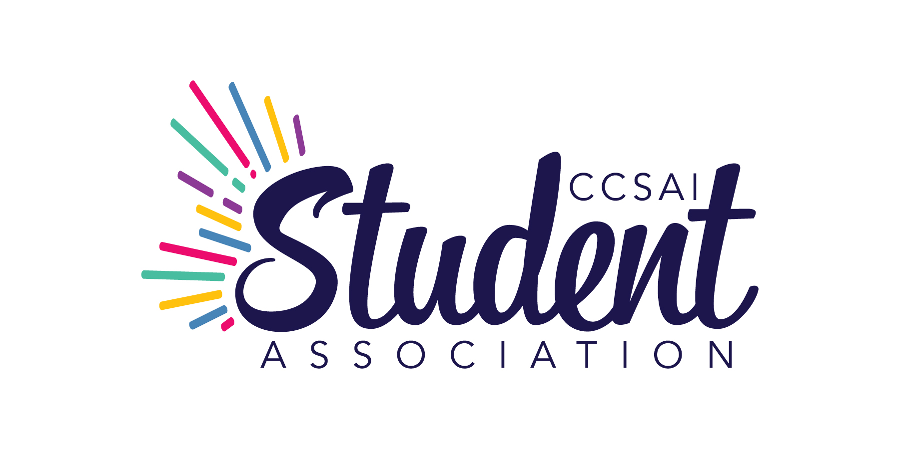
CENTENNIAL COLLEGE STUDENT ASSOCIATION INC.

FULL BOARD MEETING
Thursday, December 19, 2024 at 11:00 a.m.
Held via Zoom videoconference

MINUTES

Present: A. Adams - President
B. Kaur - Vice President, Morningside Campus
K. Singh - Vice President, Downsview Centre Campus
K.M. Herrera - Vice President, Progress Campus
R. Olawoyin - Vice President, Ashtonbee Campus
V. Eke - Vice President, Story Arts Centre
L. Routhier - Representative, Performing Arts Centre
A. Ladouceur - Indigenous Student Representative
P. Kirlik - Executive Director/CEO
D. Ip Yam - Dean of Students, Centennial College

Staff: P. Pawar - Student Advocate
E. Nolan - Manager, Events and Clubs (11:35 a.m. to 11:44 a.m.)

By Invitation: Anna Nutovich - Recording Secretary, MinuteTakers Inc.

Motions will include the count of votes for, against and abstentions. The count will be shown as follows: (FOR – AGAINST – ABSTAINED).

1. CALL TO ORDER

Notice having been given and there being a quorum present, the President called the meeting to order at 11:01 a.m. and presided as Chair.

2. LAND ACKNOWLEDGEMENT

A. Adams read out the land acknowledgment statement.

3. CONSENT AGENDA

- Remove Item 4 – Approval of Minutes.

3… On Motion by K. Singh and seconded by B. Kaur it was:
RESOLVED THAT the following items as contained in the Consent Agenda of December 19, 2024 be duly approved and adopted as amended:
- Conflict of Interest
- Approval of Agenda as amended
Motion carried (6-0-0).

4. CENTENNIAL COLLEGE UPDATE – D. Ip Yam report is as follows:

(a) Centennial Board of Governance Awards – The 2024 Board of Governors Awards of Excellence celebrate outstanding contributions across Centennial College. Congratulations to the winners, including Devansh Jaswal for Student Leadership, whose inspiring dedication exemplifies student success. This year’s six categories highlighted exceptional talent and teamwork. Winners were celebrated at a special reception on December 12.

(b) Negotiations – Ontario’s 24 colleges and the union representing academic employees (instructors, professors, librarians, and counsellors) are currently negotiating a collective agreement. As a provincial college, Centennial does not bargain directly with its unionized employees. The province mandates that the College Employer Council (CEC) act as an agent representing colleges (the employers) in centralized collective bargaining with unionized staff. The Ontario Public Service Employees Union (OPSEU) represents college academic employees, as well as support staff. Information will be posted here for students: https://www.centennialcollege.ca/about-centennial/union-announcements/2024-academic-employee-contract-negotiations

(c) Strike – Upon inquiry by R. Olawoyin, it was advised that the impact on the students will depend on the details of the strike, if any. In the event of the strike, there will be interruptions, but arrangements will also be made.

(d) Statements – K.M. Herrera inquired whether the College will be releasing a statement. It was confirmed that communication will be issued. There is also a website where information is posted.

5. POLICY 1.01 – A. Adams presented:

(a) Edits – Several edits were noted.

On Motion by K. Singh and seconded by R. Olawoyin it was:
RESOLVED THAT Policy 1.01 be approved as of today and be effective January 1, 2025.
Motion carried (6-0-0).

6. AD-HOC POLICY COMMITTEE – A. Adams presented:

(a) Executive Director Authority – K.M. Herrera proposed that the Executive Director be able to assign a role to the staff. It was clarified that staff support is required with respect to policies, etc. It was further pointed out that Executive Director already has this authority.

On Motion by K. Singh and seconded by K.M. Herrera it was:
RESOLVED THAT Policy 8.03 be approved as of today and be effective January 1, 2025.
Motion carried (6-0-0).

7. SPECIAL GENERAL MEETING – A. Adams presented:

(a) Date – The date for the Forum has been set. Time will be allocated for the Special General Meeting (SGM). The SGM will be held on March 13, 2025.

On Motion by K. Singh and seconded by K.M. Herrera it was:
RESOLVED THAT the Special General Meeting be held on March 13, 2025.
Motion carried (6-0-0).

8. INDIGENOUS STUDENT REPRESENTATIVE REPORT – A. (Mukwa) Ladouceur presented.

(a) Meetings with Students – There is a suggestion to start meeting with students to obtain an update.

(b) Policies – It was noted that a lot of policies do not have indigenous input.

(c) Strategic Plan – Feedback will be obtained from the students with respect to strategic plan.

9. CLUB RATIFIATION – E. Nolan.

(a) Korean Culture Club – The Korean Culture Club at Centennial College will serve as a dynamic hub for students passionate about exploring the vibrant and multifaceted culture of Korea. Our club will focus on both the traditional and contemporary aspects of Korean culture, providing a platform for cultural exchange, education, and community building.

On Motion by K. Singh and seconded by V. Eke it was:
RESOLVED THAT Korean Culture Club be approved.
Motion carried (6-0-0).

(b) CCSAI Noorana Bollywood Dance – CCSAI Noorana Bollywood Dance is the best way to enjoy, relax and focus. This club aims to create a dynamic and inclusive space where students can come together to explore the joy of Bollywood dance and its benefits.
(b…) The purpose is to provides an opportunity for students to learn about and celebrate Indian culture, promoting diversity, and encourage them to find some time from their busy schedule for themselves, as it not only helps to make us physically fit but also mentally active to focus on our academics and work. The mission is to provide a welcoming and inclusive space where students of all backgrounds and skill levels can come together to explore their passion for dance.

On Motion by K. Singh and seconded by V. Eke it was:
RESOLVED THAT CCSAI Noorana Bollywood Dance be approved.
Motion carried (6-0-0).

(c) Experimental Dance Company Club (Dance Performance Program) – This club aims to provide students in the dance program, as well as anyone interested in dance from all campuses, with an immersive experience that simulates the functioning and dynamics of a professional dance company. Our goal is for the club to be not only a space to practice and enjoy dance but also a support network for aspiring dancers, choreographers, and dance enthusiasts. We aspire to hold regular performances both on and off campus, allowing members to showcase their talent and create enriching experiences for participants and audiences alike.

On Motion by K. Singh and seconded by V. Eke it was:
RESOLVED THAT Experimental Dance Company Club (Dance Performance Program) be approved.
Motion carried (6-0-0).

10. EXECUTIVE DIRECTOR’S UPDATE – P. Kirlik presented:

(a) Security Agreement Renewal – The agreement was due and has been renewed. The Performance Program is in progress.

(b) Building Maintenance – Various building maintenance programs are underway.

11. PRESIDENT’S REPORT – A. Adams presented:

(a) Advocacy Month – The Advocacy Month has ended. Representatives were able to meet with Ministers and MPPs. A discussion took place with the Minister of Colleges and Universities – the affordability crisis has been discussed.

(b) CASA – The CASA was a success.

(c) Town Hall Meeting – A Town Hall meeting was held with the Minister of Education.

(d) Student Association – An update was provided on the activities of the Student Association.

(e) Indigenous Student Representative Onboarding – The onboarding has been completed.

12. IN-CAMERA DISCUSSION – discussion was held as required.

Moved by K. Singh, seconded by K.M. Herrera, to go in-camera at 1153 am. All for

Moved by B. Kaur, seconded by K.M. Herrera, to come out of camera at 1255pm. All for

13. DATE OF NEXT MEETING

The next Full Board meeting will be held virtually on a date to be determined.

Action: Board Members to submit their timetables.

14. ADJOURNMENT

There being no further business to discuss, the meeting was concluded at this point.

President – A. Adams

Executive Director/CEO – P. Kirlik

