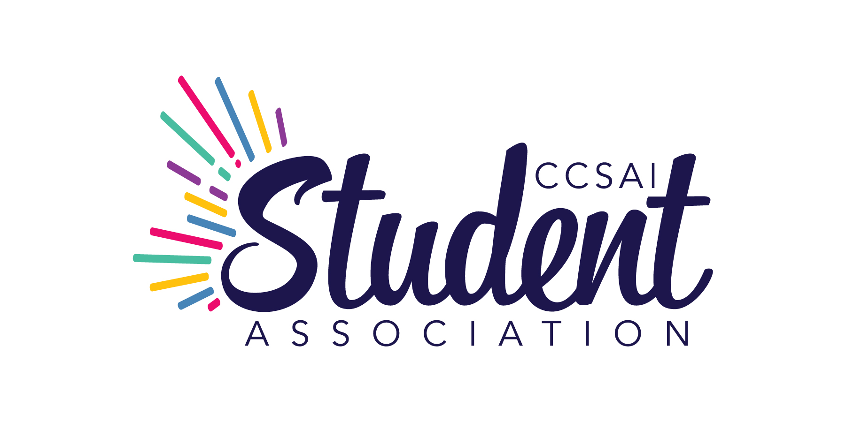

CENTENNIAL COLLEGE STUDENT ASSOCIATION INC.

FULL BOARD MEETING
Wednesday, May 22, 2024 at 12:30 PM
Student Centre Board Room, Progress Campus
941 Progress Avenue, Toronto, Ontario
Held via Zoom videoconference

MINUTES

Present: A. Adams - President
B. Kaur - Vice President, Morningside Campus
K. Singh - Vice President, Downsview Centre Campus
K. M. Herrera - Vice President, Progress Campus
V. Eke - Vice President, Ashtonbee Campus
P. Kirlik - Executive Director/CEO
L. Routhier - PAC Representative
D. Ip Yam - Dean of Students, Centennial College

Staff: J. Perri - Advocacy Coordinator
E. Nolan - Manager, Events and Clubs
P. Pawar - Student Advocate
L. Barlow - Dir. Development, Major Gifts and Campaigns
R. Mohammed - Donor Relations and Stewardship Officer

By Invitation: Karthik Selvakumar - Recording Secretary, MinuteTakers Inc.

Motions will include the count of votes for, against and abstentions. The count will be shown as follows: (FOR – AGAINST – ABSTAINED).

1. CALL TO ORDER

Notice having been given and there being a quorum present, the President, A. Adams, called the meeting to order at 12:31 p.m. and presided as Chair.

2. LAND ACKNOWLEDGEMENT

A. Adams read out the land acknowledgment statement.

3. CONSENT AGENDA

On Motion by K.M. Herrera and seconded by B. Kaur it was:
RESOLVED THAT the following items as contained in the Consent Agenda of May 22, 2024 be duly approved and adopted:
- Conflict of Interest
- Approval of Agenda
- Approval of the Minutes from last meeting dated April 25, 2024
Motion carried (6-0-0).

4. SCHOLARSHIPS AND BURSARIES – L. Barlow and R. Mohammed presented:

(a) Overview of Endowments – Principal funds deposited in an endowment are not expendable and are invested to retain and increase the principal amount. Interest earned from the investment of the principal fund is expendable and used to fund scholarships.

(b) Historical Context – The CCSAI endowment funds were initiated in 2002, with donations from CCSAI being matched 1:1 by the Ontario Government until 2011. The conditions of OSOTF and OTSS matching fund requirements were presented. A new endowment was established in April 2011 with no restrictions on how interest can be disbursed. The 2022/2023 Board of Directors reviewed all scholarships and revised the criteria to better reflect student needs, a process that continued into 2023/2024. Additionally, WIL Grants supported 10 students with $500 each in Fall and Winter 2024.

(c) Scholarships Overview – An overview of the types of scholarships created was presented. They were reviewed and accepted in 2023 to ensure each scholarship meets the needs of the College.

(d) Scholarship Disbursement – The interest from OSOTF and OTSS funds scholarships for domestic students and the interest earned from general endowment funds scholarships for international students. 175 CCSAI scholarships and bursaries were awarded in 2023-2024, totalling $185,000.

(e) Next Steps – If there are any additional changes to be reflected in the 2024/2025 scholarships, the office of development will need these by June 21, 2024. Each applicant must fill out the Doorways for Dollars application, after which applicants can apply for the scholarships that they are applicable for. The CCSAI is awaiting the proposed endowment to approve the allocation.

5. CLUB RATIFICATION

E. Nolan presented four club names for approval.

(a) Nepalese in Centennial Club – The Nepalese in Centennial club is a vibrant community hub that celebrates Nepalese culture, promotes inclusivity, and fosters connections. The club offers cultural events, community support, educational initiatives, and social activities to enrich Centennial's cultural diversity and create a welcoming environment for everyone.

On Motion by K.M. Herrera and seconded by B. Kaur it was:
RESOLVED THAT the club name ‘Nepalese in Centennial Club’ be approved. Motion carried (6-0-0).

(b) Space and Automation Student Society (SASS) – The Space and Automation Student Society (SASS) promotes research and development in automation and space across all engineering disciplines. The club provides technical know-how, support, and training for innovative projects. SASS collaborates with SEDS Canada (Students for the Exploration and Development of Space) on various initiatives, including night sky observation, closed space conferences, and industry networking events.

On Motion by V. Eke and seconded by K. Singh it was:
RESOLVED THAT the club name ‘Space and Automation Student Society’ (SASS) be approved. Motion carried (6-0-0).

(c) Water of Life Non-Denominational Christian Club – The Water of Life club is a Bible club that provides a welcoming, inclusive environment for students to explore and deepen their understanding of the Bible and its teachings. The club aims to create a supportive community where individuals from diverse backgrounds can come together to discuss, reflect, and learn from the rich historical and moral lessons found in the Bible.

On Motion by K.M. Herrera and seconded by B. Kaur it was:
RESOLVED THAT the club name ‘Water of Life Non-Denominational Christian Club’ be approved. Motion carried (6-0-0).

(d) Women’s Health and Nutrition Club – The Women's Health and Nutrition Club empowers women with comprehensive knowledge about health and nutrition, covering essential topics such as balanced diets, regular exercise, mental health awareness, and preventive health care.

(d…) Led by President Christine Doyle, a certified Holistic Health Coach trained by the Institute for Integrative Nutrition, the club provides women with the guidance and support needed to effectively navigate their health journeys.

On Motion by B. Kaur and seconded by K.M. Herrera it was:
RESOLVED THAT the club name ‘Women’s Health and Nutrition Club’ be approved. Motion carried (6-0-0).

(e) CCSAI Global Business Mavericks Club – The Global Business Mavericks Club is dedicated to supporting students in the demanding Global Business Management program. Aiming to ease the stress and confusion students may face, the club provides a space for peer support and guidance. The focus is on meeting the specific needs of GBM students by offering tailored resources and assistance to ensure their academic and professional success in this dynamic and diverse field.

On Motion by K.M. Herrera and seconded K. Singh by it was:
RESOLVED THAT the club name ‘CCSAI Global Business Mavericks Club’ be approved. Motion carried (5-0-1). K. Singh abstained.

(f) Creative Writing Club – The Creative Writing Club is dedicated to exploring and creating various forms of creative writing, including fiction, nonfiction, poetry, and prose. Members can share their work, exchange resources, and participate in writing contests through online platforms. The club also aims to organize in-person gatherings at the campus library for events like meet and greets, spoken word poetry sessions, and group discussions centered around books selected from the library's recreational section.

On Motion by B. Kaur and seconded V. Eke by it was:
RESOLVED THAT the club name ‘Creative Writing Club’ be approved. Motion carried (5-0-1). K. Singh abstained.

6. DISSOLVING ADVISING COUNCIL – J. Perri presented:

(a) Overview – This past year, the advisory council was re-implemented, which intended to provide guidance on indigenization, equity, diversity, and inclusion (IEDI). During this process, it became evident that the council needed further improvement. Consequently, it was decided to pause its activities, refine its structure and processes, and prepare it for re-implementation in the near future.

On Motion by V. Eke and seconded B. Kaur by it was:
RESOLVED THAT the Advising Council be dissolved. Motion carried (5-0-1). K.M. Herrera abstained.

7. CENTENNIAL COLLEGE UPDATE – D. Ip Yam reported on the following:

(a) Ontario Competition Winners – Students and faculty celebrated the 2024 Skills Ontario Competition, an opportunity for top students to showcase their excellence in their fields. This month, Centennial achieved a remarkable 21 medals: three gold, nine silver, and nine bronze. Additionally, Centennial received The College Award of Distinction for the sixth consecutive year. Gold medallists include: Darren Bergado (Automation and Control), Adam Duguay (Heavy Equipment Service), Chau Ciang Liang Huang (Renewable Energies – Team), Andrea del Pilar Ramirez Garcia (Renewable Energies – Team). Congratulations were extended to all the medal winners and the dedicated staff and faculty members who tirelessly prepared everyone for the competition.

(b) College President Honours Centennial Students at Scarborough Walk of Fame – President Craig Stephenson attended the Scarborough Walk of Fame event to present the Rising Star awards to two Centennial students and young leaders shaping the community's future. Congratulations were extended to all the Scarborough Walk of Fame inductees who are making Scarborough a better place to live, work, and play.

i) Fariha Atqiya co-founded a non-profit organization, FeminSTEM, in 2018 to introduce girls to science, technology, engineering, and mathematics (STEM), aiming to close the gender gap.

ii) Swabir Shariff co-established The Good Guides – Inner City Youth Mentoring, a Toronto-based non-profit, engaging youth in community development and putting them on the front lines of change.

8. PRESIDENT’S REPORT – A. Adams presented:

(a) Canadian Alliance of Students Associations (CASA) – Board members attended a valuable CASA conference, where they engaged in advocacy and EDI training, highlighting CASA's benefits for student leaders. They reviewed yearly accomplishments and advocacy successes. CASA represents nearly 700,000 students across Canada. A. Adams was elected to serve on CASA's Board. The advocacy priorities discussed, included funding for research, housing, food security, and student affordability. Notably, in July 2024, Centennial College will be the first Ontario college to host a CASA conference focused on developing policy priorities for the year.

(b) OSV Update – The OSV conference is scheduled for May 25, 2024. Additionally, a policy strategic development conference will take place in July 2024.

(c) Pride Month – Pride Month will be celebrated on June 3, 2024. CCSAI has donated a significant amount to support the events and activities.

(d) Portfolios – Portfolios have been allocated as follows:

i) Federal: Primary lead is L. Routhier and secondary lead is B. Kaur.
ii) Provincial: Primary leads are K.M. Herrera and V. Eke.
iii) Municipal: Primary lead is K. Singh.
iv) Primary Communication: V. Eke and K.M. Herrera.
v) Treasurer: K.M. Herrera.

9. EXECUTIVE DIRECTOR’S UPDATE – P. Kirlik presented:

(a) Convocation – P. Kirlik congratulated all the graduates of this year, including those Board members who have graduated.

(b) Audit Update – The audit will be completed soon. The audited financial statements are expected to be presented for Board approval in July 2024.

10. DATE OF NEXT MEETING

The next Full Board meeting will be held virtually on Thursday, June 27, 2024 at 10:00 a.m.

11. ADJOURNMENT

There being no further business to discuss, the meeting was concluded at 2:00 p.m. on Motion duly made and seconded.

President – A. Adams

Executive Director/CEO – P. Kirlik

